Testing report
sample.txt content
0 0 2
0 0 7
0 0 5
1 0 4
1 0 2
1 1 3
1 1 4
0 1 3
0 0 4
0 0 5
1 0 6
1 1 7
1 1 8
0 10 10
1 5 15
1 1 2
1 1 3
1 1 4

Result of simulation
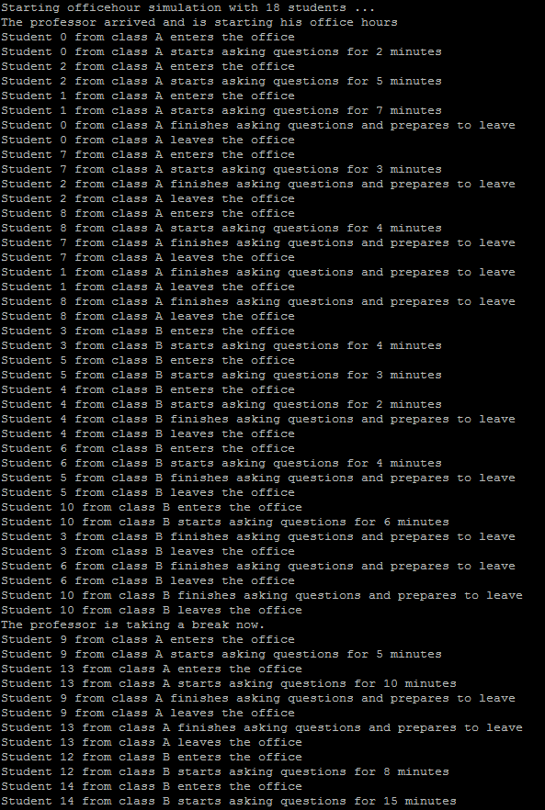
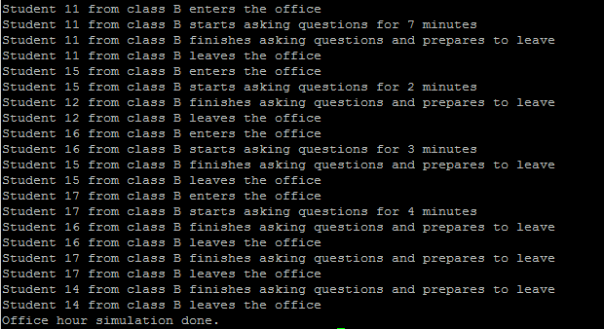

Explanation

We can see that professor accepts 5 consecutive students from class a (students 0,1,2,7,8)
Then professor accepts 5 consecutive students from class b (students 3,4,5,6,10)
Then professor takes a break
Then professor again accepts students from class a (students 9 and 13)
Then as there is not any student from class a, professor accepts students from class b (students 11, 12, 14, 15, 16, 17). He is accepted more than 5 consecutive students from class b, because there are no students from class a.

